Systematic Transferring Process from AC (HBL) to SLC1
- In Hub Application, go to Support and access Transfer Report.
- KBB Staff select date range, indicate Location and click Retrieve button
- KBB Staff click Print button to print Transfer Report (from Loaner1 Location)
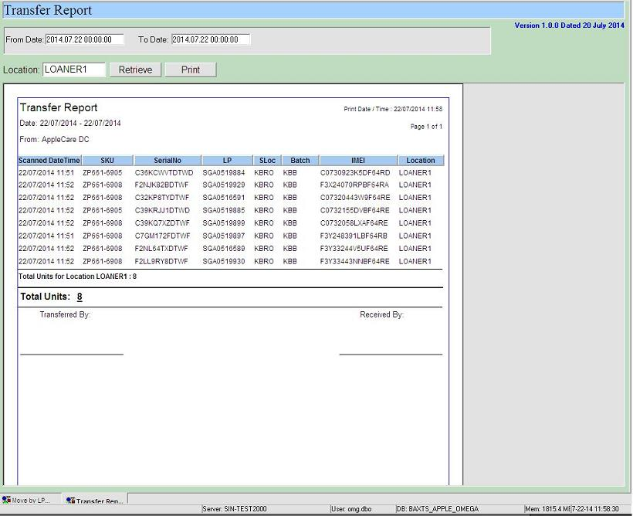

- In Hub Application, go to Support and access Move by LP.
- SLC1 Staff perform Move to SLC1_STAGE after they receive units from Harbourlink
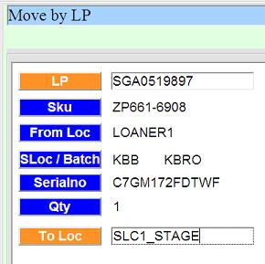

- SLC1 Staff perform Move upon segregation
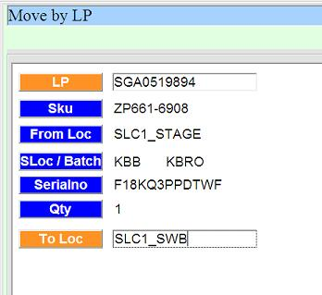

- SLC1 Staff will receive error message if they try to move to non SLC1 location
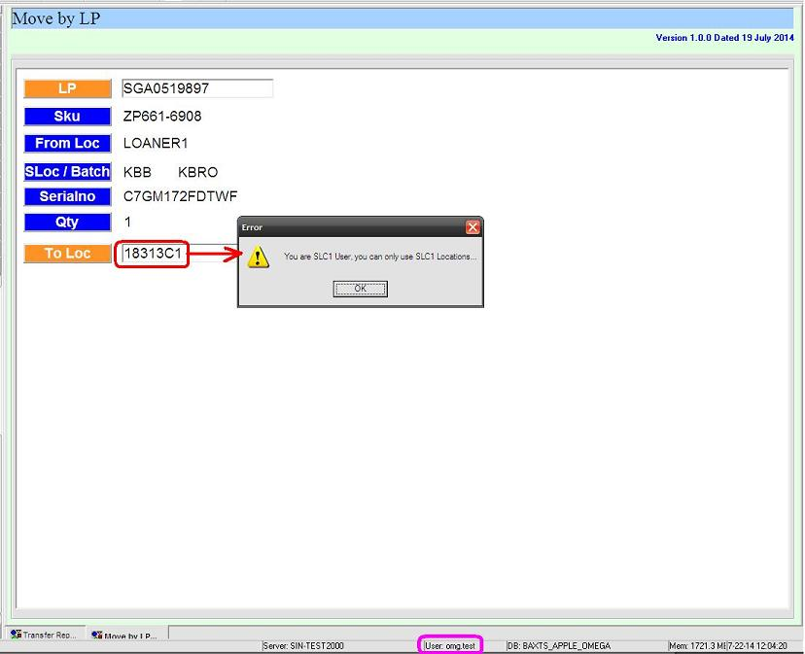

- SLC1 Staff select date range, indicate Location and click Retrieve button
- SLC1 Staff click Print button to print Transfer Report (from SLC1 Locations)
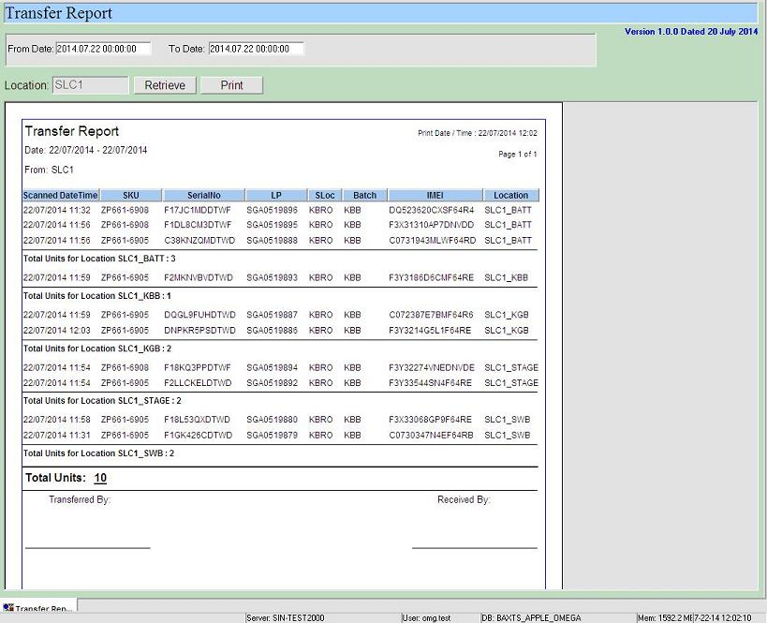

- KBB Staff perform Move after units returned from SLC1
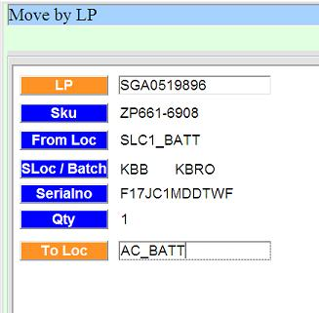

For IT: Additional Notes / Setup:

New Locations Setup SQL

SLC1 Users Setup SQL

